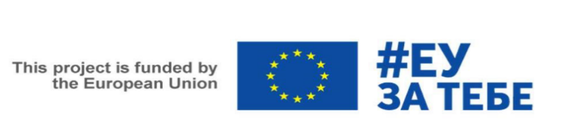
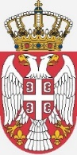
REPUBLIC OF SERBIA
MINISTRY OF AGRICULTURE, FORESTRY AND WATER MANAGEMENT MINISTRY OF FINANCE
Department for Contracting and Financing of EU Funded Programmes

EU FUNDED TWINNING PROJECT
“Strengthening and adaptation of administrative capacities for the introduction of the Organization of Agricultural Markets”

Twinning number: SR 18 IPA AG 01 21

Is seeking to recruit Language Assistant to the Resident Twinning Advisor (RTA)

Framework of the Job:

The Ministry of Agriculture, Forestry and Water Management (MAFWM) and the Agency for Restructuring and Modernisation of Agriculture (ARMA) from Poland with partners from Lithuania and France intend to carry out a 24 month Twinning Project. The project is being implemented in the framework of the Instrument for Pre-Accession Assistance (IPA), a programme funded by the European Union.

The main objectives to be achieved by this project are, first of all, the growth of agricultural production and stability of producers’ incomes, as well as an increase of competitiveness while adapting to the requirements of domestic and foreign markets and the technical and technological progress of the agricultural sector.

The specific objective of the project is to strengthen the capacities of the Ministry of Agriculture, Forestry and Water Management (MAFWM) regarding the implementation of the Common Market Organization mechanisms, in line with the EU acquis.

The Ministry of Agriculture, Forestry and Water Management (MAFWM) will host
a Resident Twinning Advisor (RTA) and a team of experts for the duration of the project.

Status of the position:

- Duration: 24 months (start date: May 2022)
- Contractual nature of the job: Independent consultant, on the basis of the standard IPA- ENPI contract for services. The language assistant will be self-employed and will undertake full responsibility for the payment of all taxes and obligations deriving from the legislation in force, including for those related to medical and social insurance. They shall not have been in any contractual relation with the Beneficiary Country public sector during at least the 6 months preceding their hiring
- The assignment is full time and the RTA language assistant contract will run from the date of the signature of his/her contract and throughout the period of the Twinning contract. The RTA language assistant is appointed on a probation period of 3 (three) months from the date of commencement of employment. During this period the employee’s performance, skills, behaviour, adaptability, knowledge and health will be evaluated and any shortcomings in this regard during the probation period will be sufficient reason not to extend the contract beyond the probation period.
- Place of work: MAFWM of the Republic of Serbia venue (to be confirmed)
Tasks of Language Assistant:

- Overall purpose: To give administrative, accounting support the Resident Twinning Advisor (RTA) in his implementation of the Twinning Contract and in particular to support effective delivery of the Twinning Contract, ensure good communications and co-ordination between the Twinning Partners. Give administrative support to the Experts involved in the project.
- language assistance to the RTA and visiting Short-Term Experts (STE);
- Translation of written materials with relation to the project in Serbia and English (possibly also in Russian);
- Interpretation during Short-Term Experts (STE) missions to Serbia, meetings, workshops, seminars, trainings and other project events;
- Develop and maintain close working contacts with Beneficiary Country officials involved in each of the activities and the project management;
- Assist in other translation/interpretation tasks assigned to him/her by the RTA.

Requirements for Language Assistant:

- The RTA language assistant may not have or recently (past six months) have had any contractual relation with the beneficiary administration, namely the Ministry of Agriculture of the Republic of Serbia;
- University level education;
- Fluency in Serbian and excellent English is essential.;
- Ability to communicate effectively in these languages, including good drafting skills, management and organisation of staff;
- Experience in Serbian – English v.v. interpretationand translation services;
- Good computer skills (in particular Word, PowerPoint and Excel) and building databases o registers;
- Ability to work effectively in an international environment proved by a minimum of 3 (three) years of referenced professional experience.

The following skills will be considered an asset for Language Assistant:

- Knowledge of and/or experience in the Public Administration or private business sectors;
- Work experience in international organizations or project and/or relationship with international business;
- Work experience at least for 2 (two) years in working in the field of agriculture and/or agro-food sector (i.e. direct support, rural development, trade mechanism or market organisation);
- Clean driving licence and local knowledge.
How to apply:
The interested candidates are requested to submit their a motivation letter and detailed Curriculum Vitae, both in English by 25th of May, 2022 via e-mail to the following addresses:
vygantask@zum.lt (Mr. Vygantas Katkevičius Residential Twinning Adviser)
and in copy to: dawid.ciupak@arimr.gov.pl (Mr. Dawid Ciupak Project Leader)

Only short listed candidates will be notified and will be invited to attend an interview. Interviews are tentatively scheduled to take place in May in Belgrade or online by means of video conferencing.

